4/6/2017

Paryag Mehta (Net ID: pxm174430)

Business Data Warehousing

Assignment -3

Prof: - Kashif Saeed

**Universe Design Tool**

The universe for the E-R model is done through the Universe Design Tool.

There was 1 loop, 5 fan traps and 6 chasm traps.

1. **Universe(E-R Model) using Universe Design Tool:**

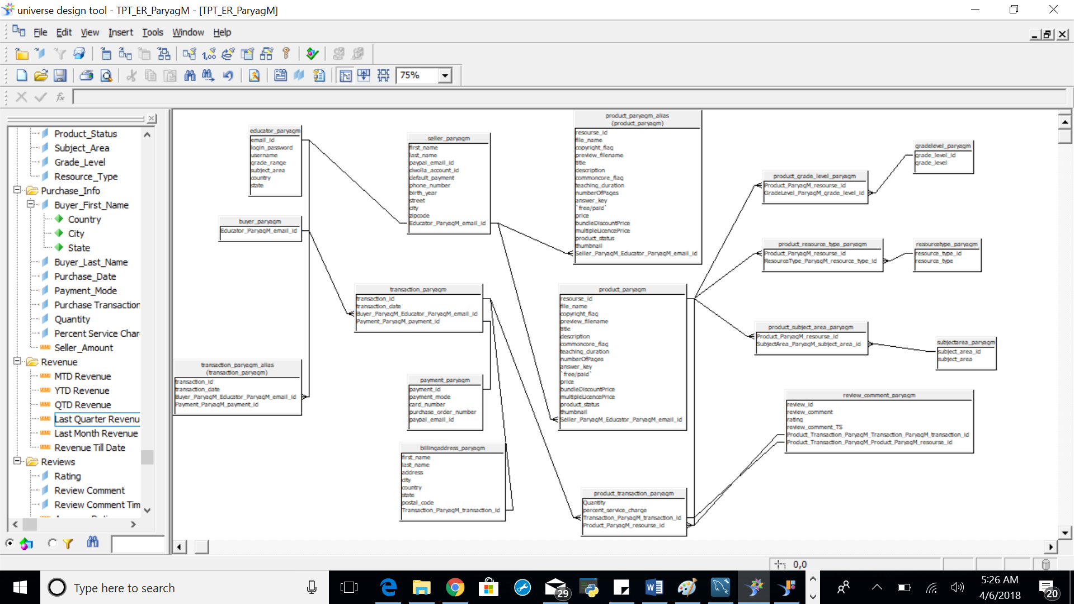

**Loop:**

Since there is no small lookup table to resolve the loop, used context to resolve the same.

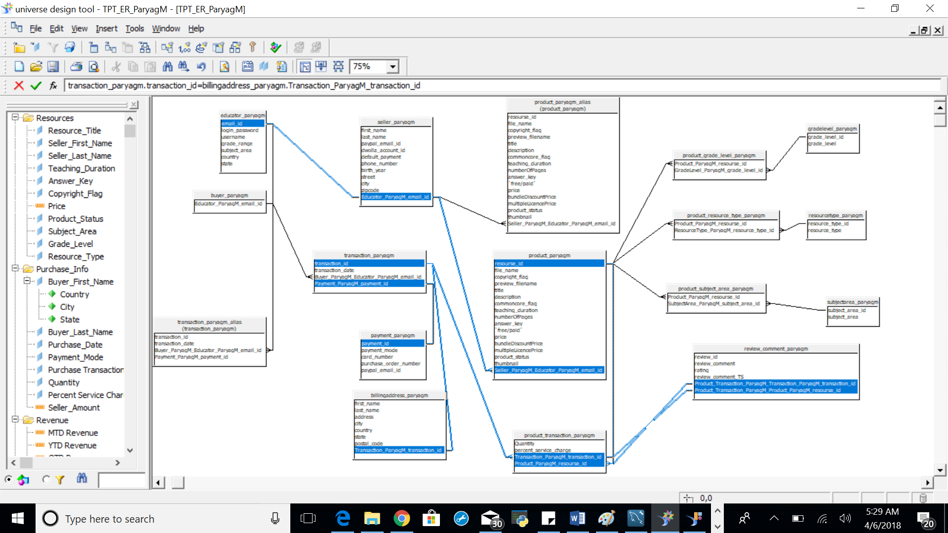

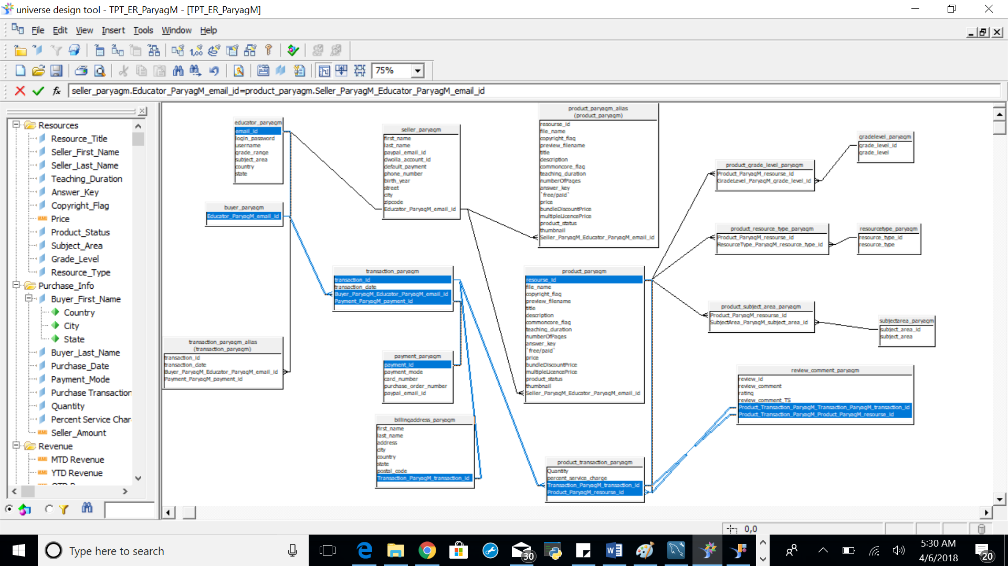

**Fan Trap:**

There are 5 fan traps in the universe; to resolve the fan traps, transaction_paryagm table as well as product_paryagm table have been aliased

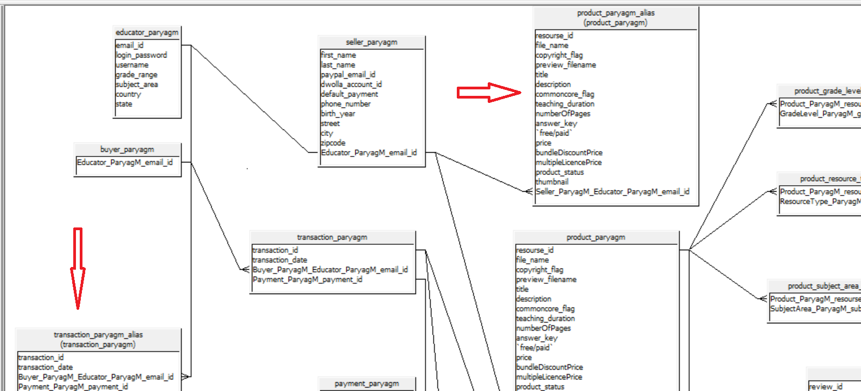



**Chasm Trap:**



To resolve the chasm traps, contexts have been defined

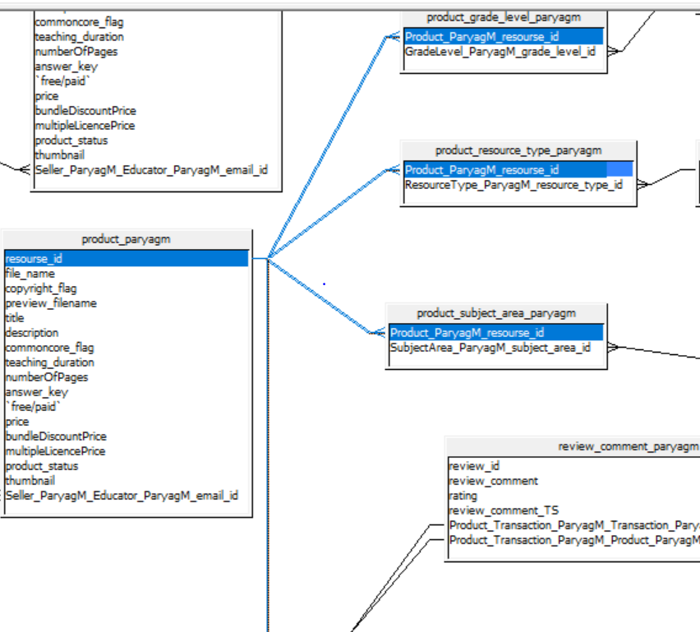

1. **Universe objects snapshot**



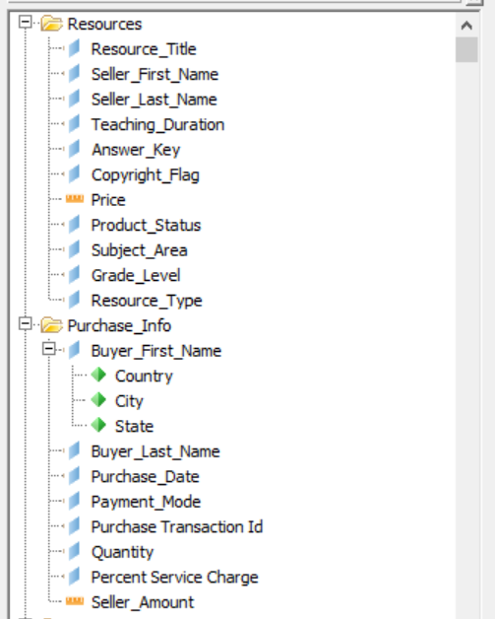

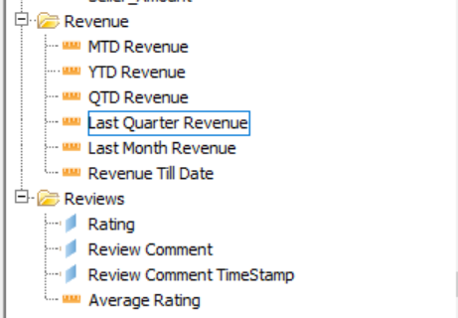

1. **Snapshot of the successful parsing of universe**

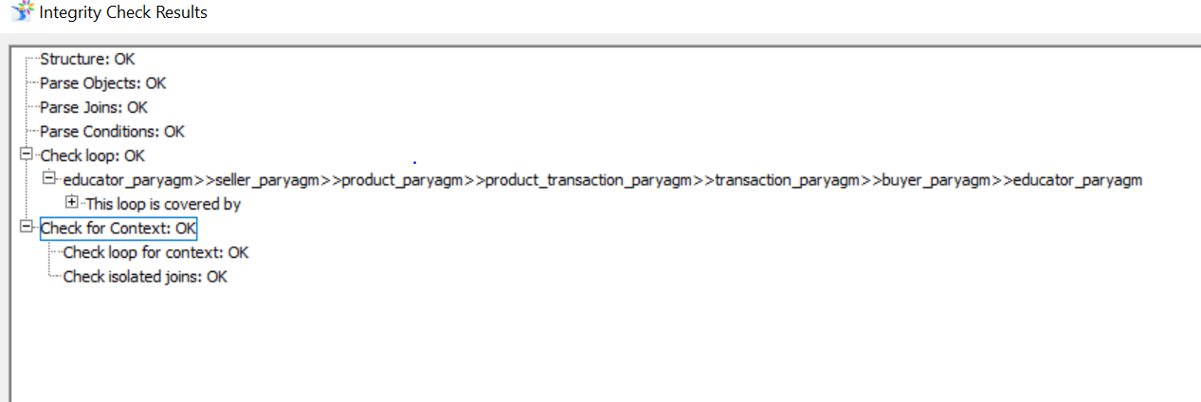

1. **Snapshot of the calculated file**

Snapshot of MTD Revenue field:

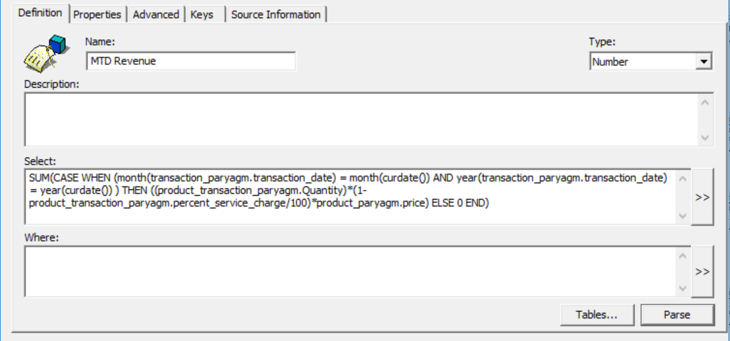

Snapshot of YTD Revenue field:

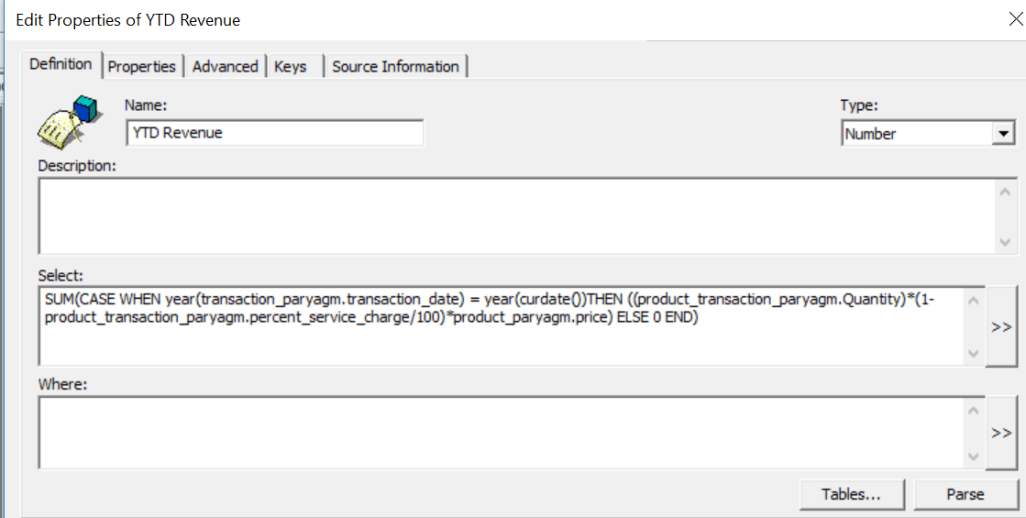

Snapshot of QTD Revenue field:

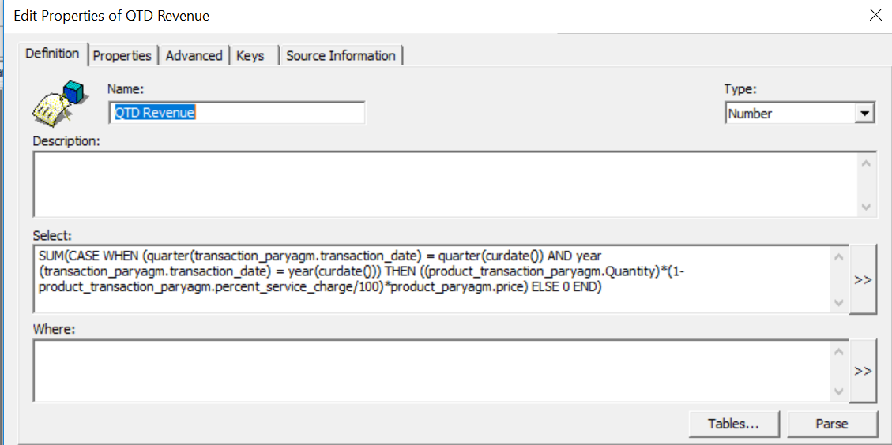

Snapshot of Last Quarter Revenue:

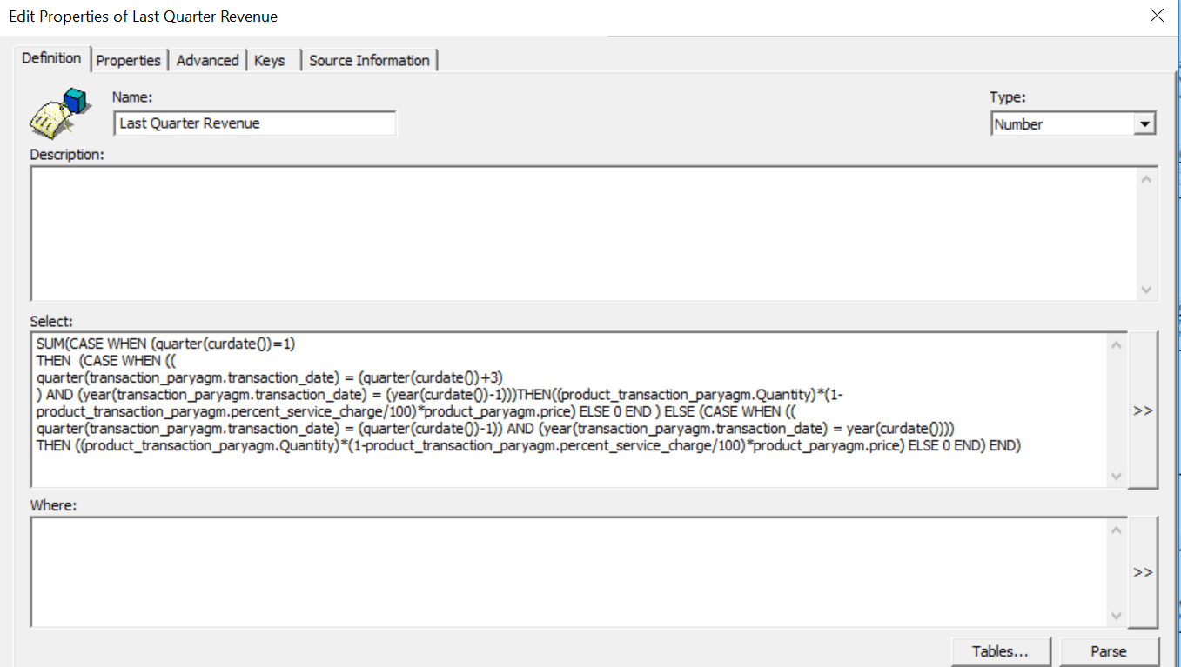

Snapshot of last Month Revenue:

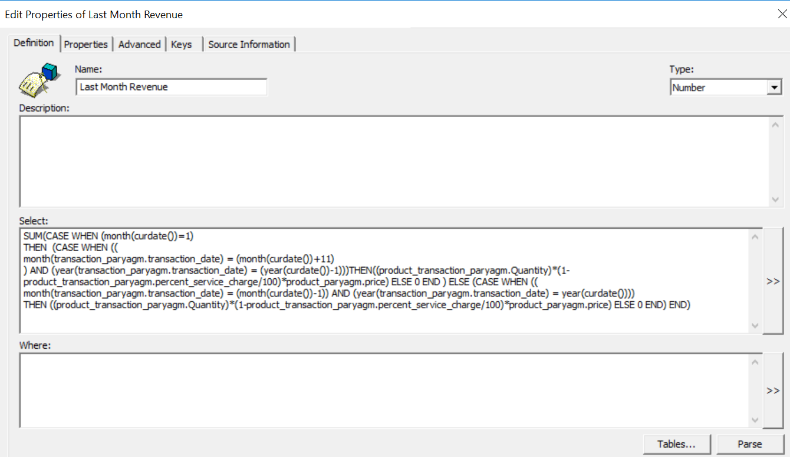

**Webi result of calculated fields:**

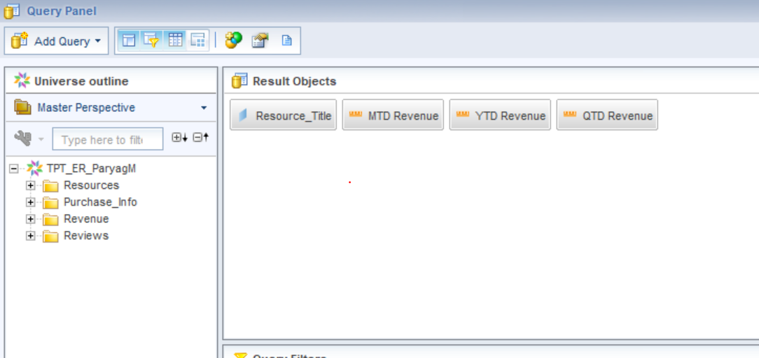

**Results:**

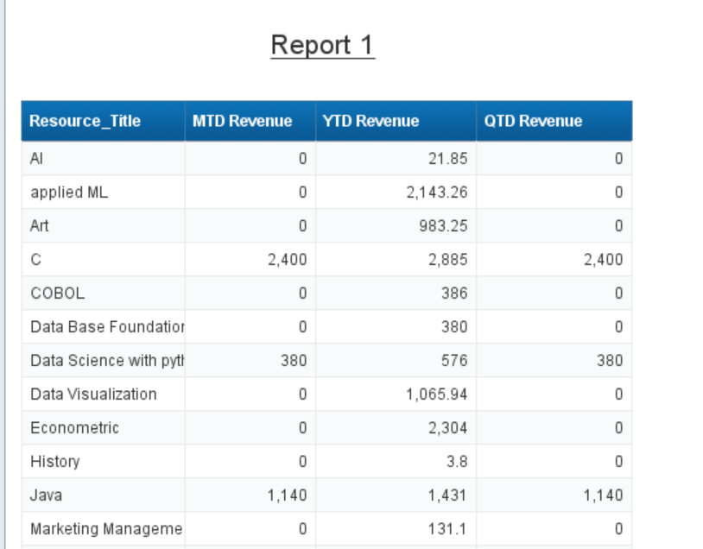

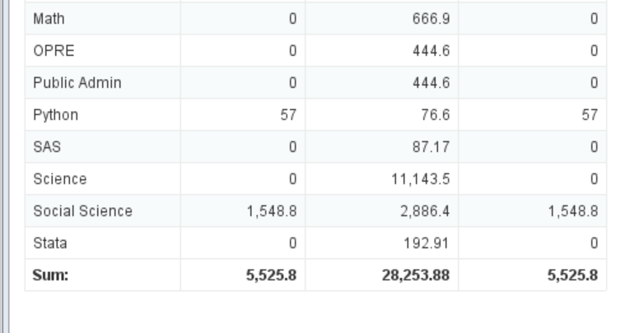



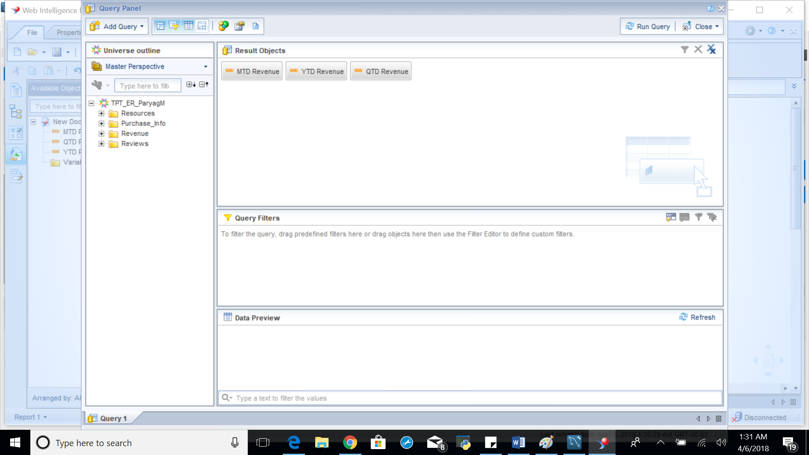

**Result:**

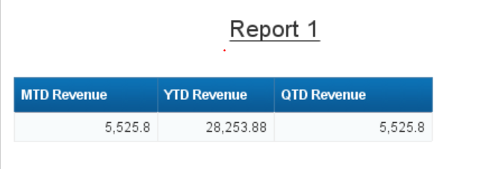

If you look at the above screenshots, sum of the individual MTD, YTD and QTD Revenue for each product is same as summarized Revenue

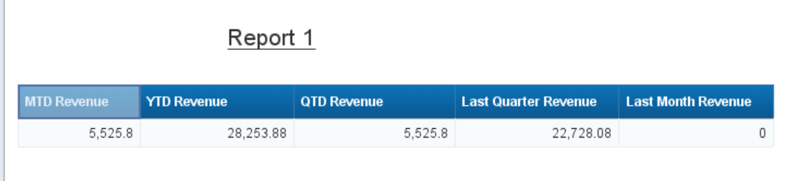

The QTD Revenue gives the revenue for this quarter(Q2) and the YTD Revenue giving the Revenue for current year (Q1 and Q2); and the Last Quarter Revenue is the difference of YTD (Q1 + Q2) and QTD(Q2). Hence the calculated fields are giving the correct output.

**Information Design Tool**

The Dimensional Model is designed using the Information Design Tool. Thera are two fact tables and hence two contexts defined to resolve the loop.

1. Universe structure snapshot

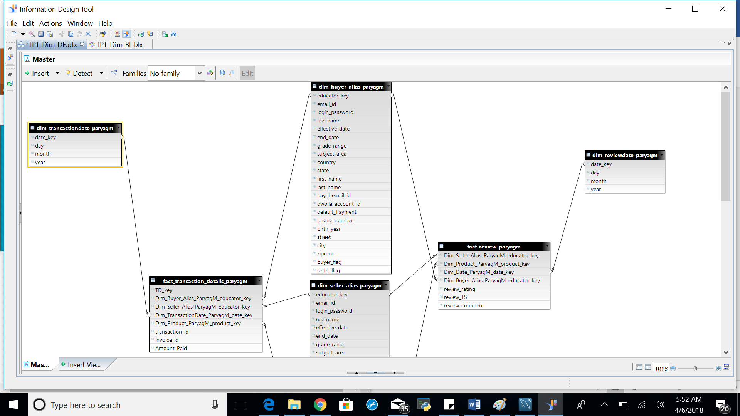

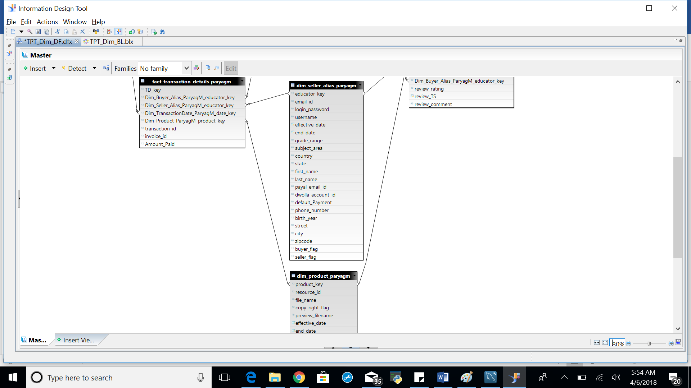

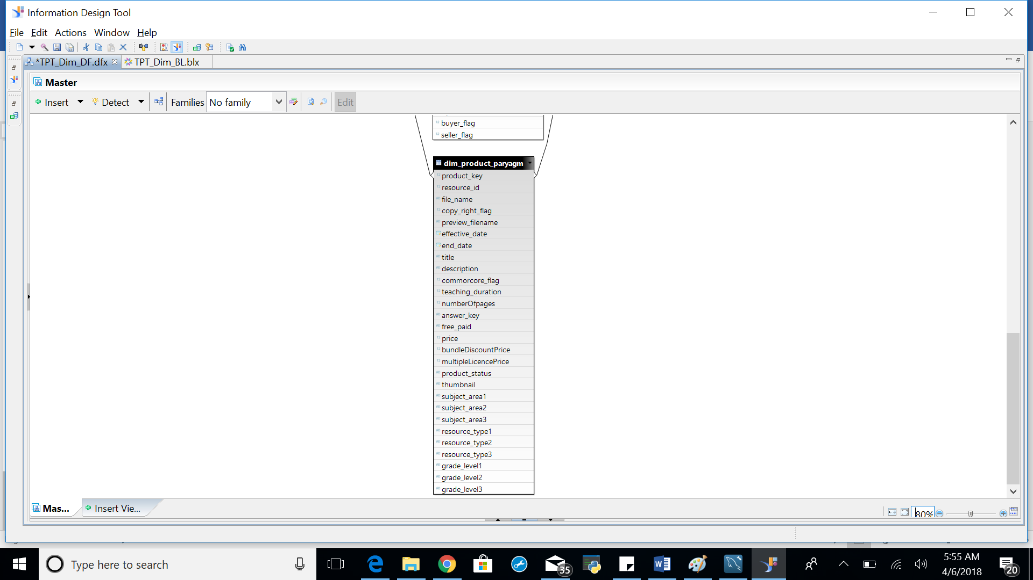

1. Universe objects snapshot

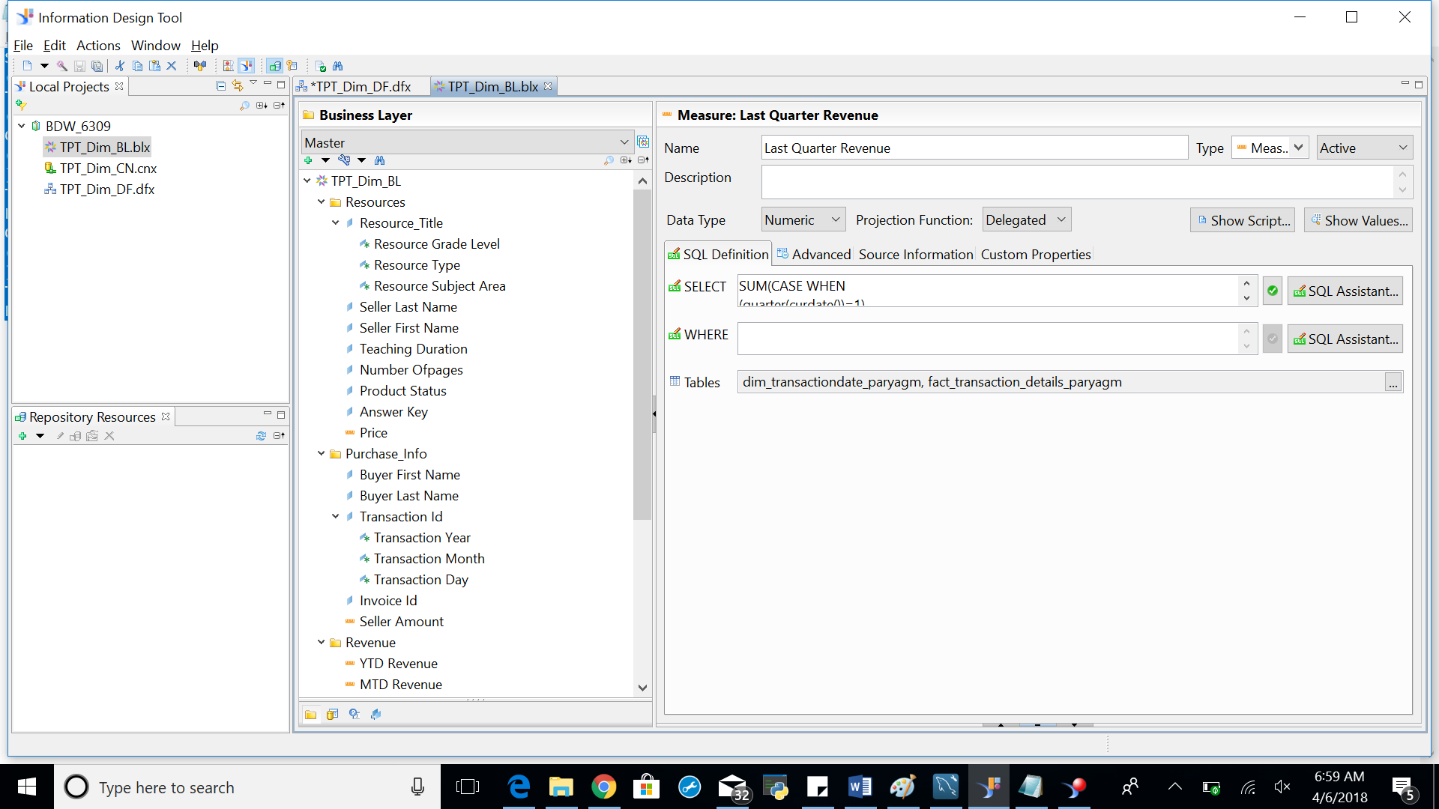

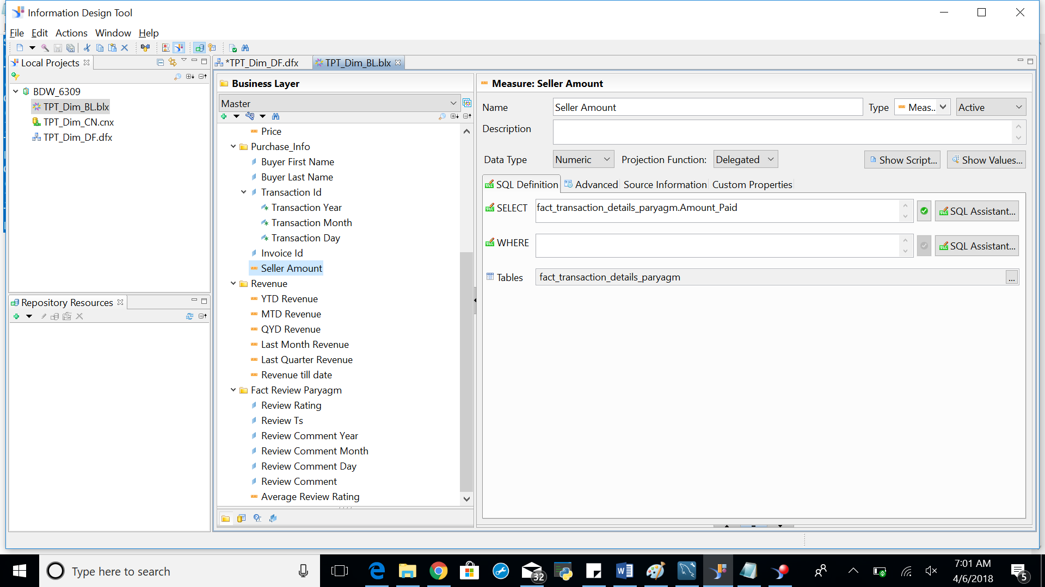

1. Snapshot of the successful parsing of universe

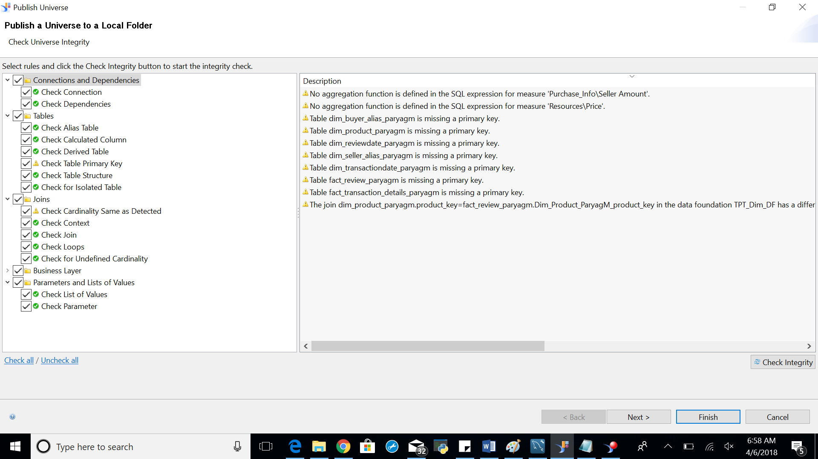

1. Snapshot of the five calculated fields

**Snapshot of MTD Revenue field:**

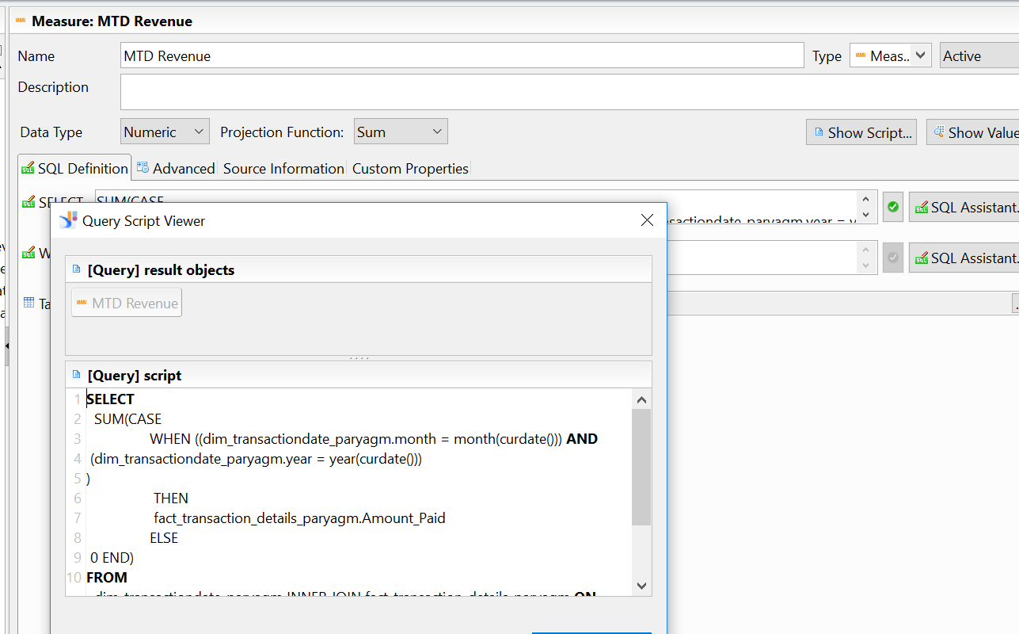

Snapshot of YTD Revenue field:

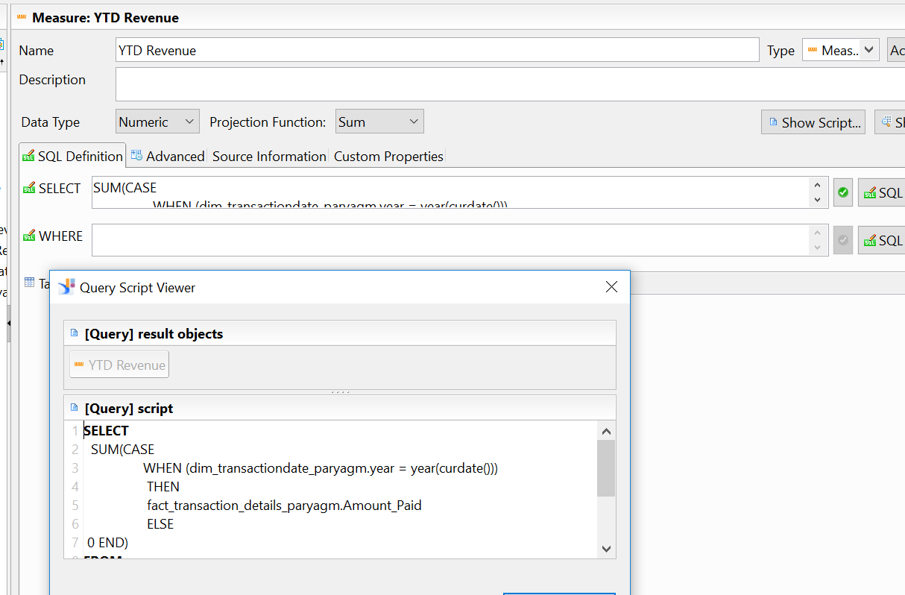

Snapshot of QTD Revenue field:

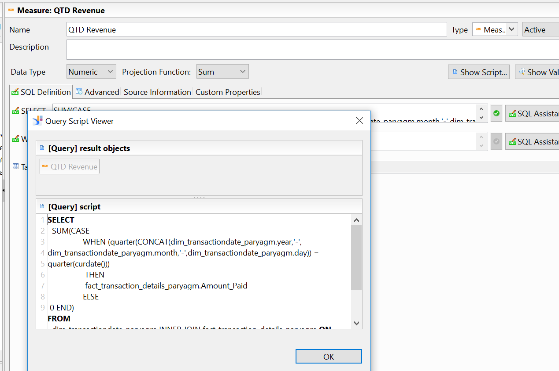

Snapshot of Last Quarter Revenue:

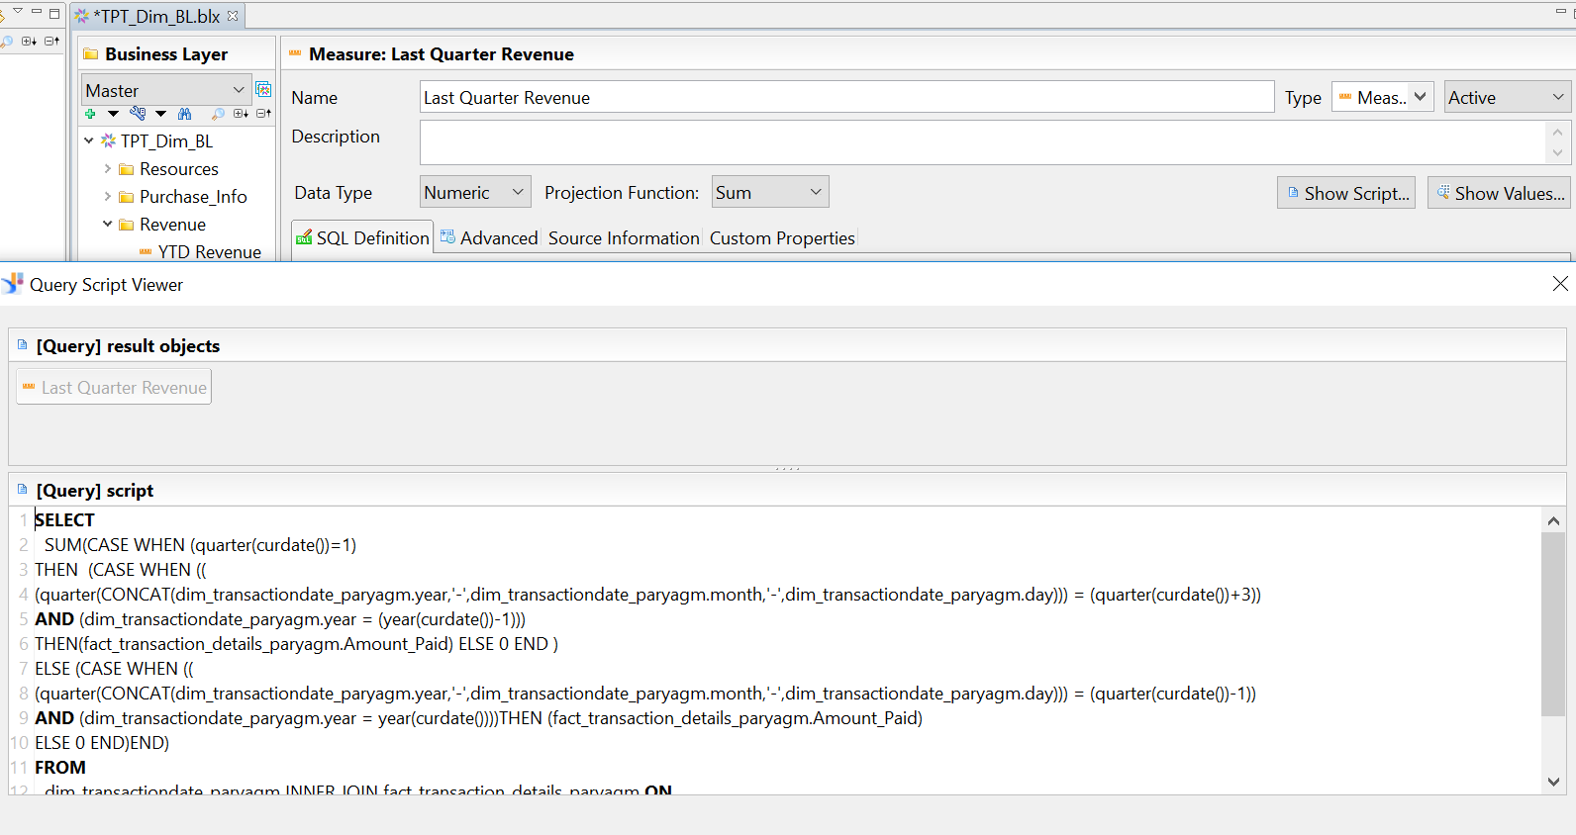

snapshot of last Month Revenue:



**Webi results verification:**

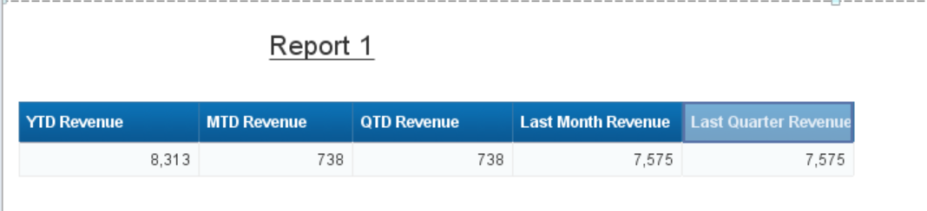

In the database we only have transaction for the month of March,2018 and April 2018. The values in the screenshot above verifies that **YTD Revenue = MTD Revenue + Last Month Revenue. Also, YTD Revenue = QTD Revenue + Last Quarter Revenue.**